PRESS RELEASE

Quantum physics in candy blue: this is how cutting-edge innovation is done
Enterprise and leading-edge research come together for a large international project. A new study published in ‘Science Advances’ reports the work of scholars at SISSA and CNR-IOM who used an unprecedented approach to help identify a new natural colourant to produce famous chocolate ‘confetti’ candies.

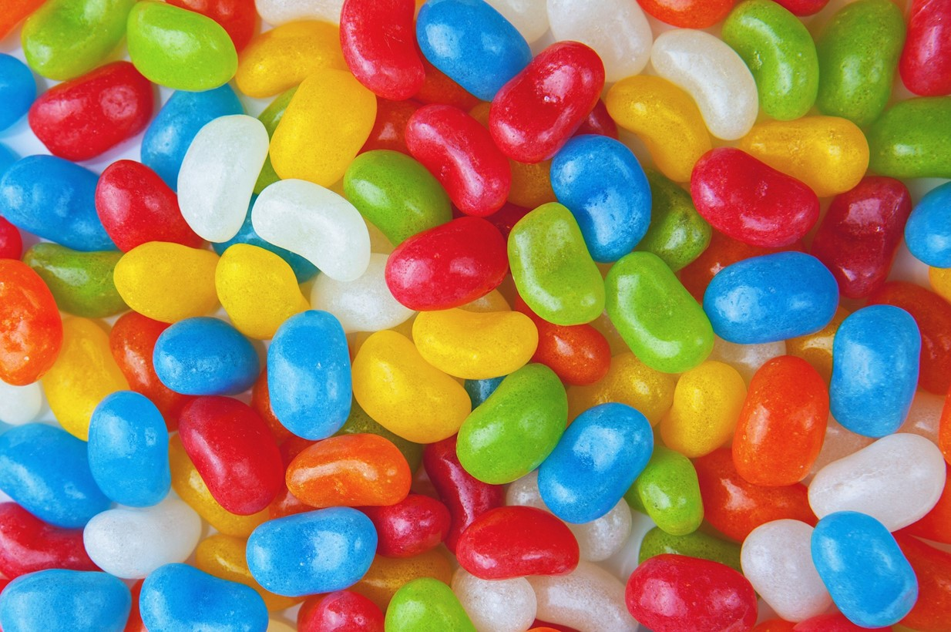

Trieste, 12 April 2021

The sophisticated and abstract tools of theoretical physics were used in an innovative applied research project: to identify a natural colouring to produce chocolate ‘confetti’ candies. This was the task undertaken by the scientists at SISSA and CNR-IOM in a research that translated scientific excellence into produced innovation in the most refined and unexpected manner. The work by SISSA and CNR-IOM was part of a large international collaboration whose results were just published in the journal ‘Science Advances’.
In their investigation, the research group in Trieste used computer simulations based on the principles of quantum mechanics to identify the molecular mechanism underlying the different shades of blue in plants, from the delicate tint of flowers to the intense purple of black raspberries, eggplants, or red wine. Specifically, the research group discovered what changes had to be made to the structure of anthocyanin – the pigment responsible for these colours – to obtain different shades of colour. This work allowed a major food company, Mars Wrigley, to patent a natural anthocyanin-based alternative to the artificial ‘Brilliant Blue’ normally used to colour their chocolate candies. In particular, the work done by SISSA and CNR-IOM helped laboratory chemists aim in the right direction, suggesting them the structure of the pigment that would produce the desired tone of colour. The molecule in question is present in abundance in red cabbage, from which it will be extracted to produce the colouring agent.

Theoretical physics for novel applications

‘The special aspect of this work’, explained Professor Stefano Baroni, who leads the SISSA-CNR-IOM research, ‘is that we used extremely sophisticated theoretical principles, normally employed for entirely different purposes, to find a solution to a seemingly trivial problem that had a great impact on the food industry. It was a new kind of collaboration for SISSA, that lasted a good 5 years. This project, in which academia and business worked together for a common purpose, marks an important path for our school and for science in general. It also highlights the importance of basic research, which rarely leads to direct application but, at the same time, allows the development of tools and ideas that may turn out to be extremely useful in the most diverse settings, as happened in this case.’

Just one twist and blue is bluer: searching for a natural colourant

In this project, the SISSA-IOM-CNR researchers started with an observation: ‘In the plant world, blue is a relatively rare colour, and many of the shades from light blue to dark violet are expressed by the same class of molecules: anthocyanins. Why the same natural colouring can be expressed in such a broad range of different tones, however, was a mystery’, professor Baroni explained. ‘Anthocyanins have a rather simple chemical structure: the molecules are formed by three rings made up mainly of carbon, to which are bonded other atoms or secondary groups such as sugars and organic acids. Thanks to our simulations, we saw that the colour produced by the pigment is bluer the greater the distortion of the chemical bonds joining the three rings. By appropriately functionalizing the molecules with secondary groups that cause this “twist” in the structure in a more or less accentuated way it is possible to obtain more or less bright blues. This previously undiscovered evidence allowed us to point laboratory chemists in the right direction to get the right colour. They then went on to identify this property in plants, specifically red cabbage, so as to extract it to use to colour the candy’.
This research is part of an international effort that sees the European legislation gradually replacing artificial colourings with natural ones. In this case, the procedure has already been patented.

Knowledge transfer for industry and society

‘“Science for industry” or, more generally, “Science for society” is the motto that describes the mission of transferring knowledge for innovation’, explained Professor Gianluigi Rozza, Director's Delegate for Innovation, Valorization, Scientific and Technological Transfer and Industrial Cooperation, and Coordinator of the Mathematics Area at SISSA.
‘With these success stories, SISSA is creating a virtuous bridge between its world-class excellence in basic sciences and the promotion and application of this very excellence in society, contributing to the improvement of products and processes through innovation, with an eye towards sustainability. These activities also facilitate the placement of our talent and help increase our school’s prestige and its impact on society’.
LINK:  The scientific paper  IMAGE  Credits: FoodyFactos for Pixabay | SISSA  Scuola Internazionale  Superiore di Studi Avanzati  Via Bonomea 265, Trieste  W www.sissa.it  Facebook, Twitter  @SISSAschool | CONTACT  Nico Pitrelli  → pitrelli@sissa.it  T +39 040 3787462  M +39 339 1337950  Donato Ramani  → ramani@sissa.it  T +39 040 3787513  M +39 342 8022237

